TKR College of Engineering & Technology (Autonomous)
Department of Computer Science and Engineering
CSE-A | Batch A11 (CSE, Section A)
AutoSecAI: Autonomous Pull Request Analysis for Security, Vulnerability Detection, and Code Quality using Multi-Agent LLMs
(AutoSecAI)
S.No. | Student name | Roll / hall ticket no.
1 | CHEPURI RISHIVARDHAN | 23K91A0553
2 | BODA SANDEEP | 23K91A0539
3 | DHARAVATH SEETHARAM | 23K91A0562
4 | NARISIMHA REDDY | 24K95A0501
Under the guidance of: P. KISHORE, [DESIGNATION]
METHODOLOGY, NOVELTY AND KEY CONTRIBUTIONS
This document describes how AutoSecAI works from end to end, why its algorithms were chosen, what is new in it compared with the base paper, and the contributions of the project. All figures are measured values from the project's own artefacts (docs/REPORT_FACTS.md).

1 Overall Methodology
AutoSecAI turns a code change into a reasoned review. The method has two parts. Preparation is done once, before the product is used: a labelled corpus of Python functions is generated, fourteen metrics are measured on it, features are selected, the classes are balanced, nine classifiers are trained and the best one is stored together with a report. Use happens for every pull request: the change is parsed, seven agents analyse it in sequence, and the result is a score, a verdict, explained findings and verified patches. A second use, the codebase assistant, indexes a repository and answers questions with cited locations.
The central idea comes from the base paper [1], which showed that a small set of source-code metrics predicts which functions are vulnerable. The paper applies the idea offline to C and C++ functions. This project applies it inside the pull-request workflow and combines it with two other kinds of evidence: an abstract-syntax-tree analyser with taint tracking, which names the exact line and the weakness class, and a rule knowledge base, which supplies the explanation, impact and fix. Each kind of evidence is weak alone, and the combination is evaluated later in this document.
Table 1: Pipeline of AutoSecAI
Step | Method | Output
1 Ingest | Unified-diff parser, before/after diff, zip or folder reader, GitHub pull-request download | List of changed files with hunks and added line numbers
2 Static analysis | Python AST, taint levels 0-3, 30 security rules, quality rules; regex rules for JavaScript, PHP and Java | Findings with rule, line, confidence, optional fix
3 ML risk | 14 metrics per function, Min-Max scaling, stored XGBoost model, type classifier | Probability, predicted type and top drivers per function
4 Reasoner | Knowledge-base lookup, source-to-sink description, corroboration with the model | Explanation, impact, remediation, CWE, OWASP
5 Remediation | Fix generators for SQL, shell and similar calls; apply to a copy; analyse again | Patch and a verified flag
6 Quality | Complexity, nesting, size, error handling, dead imports | Maintainability findings
7 Judge | De-duplication by file, line and CWE; weights; exponential score; verdict rule | Score 0-100, verdict, PR comment
8 Report | Markdown, SARIF 2.1.0, JSON, CSV, patched files; SQLite history | Exports and stored review

The seven agents are ordinary Python functions that append an entry (agent, role, seconds, summary, details) to a shared trace; none is a language model. An optional language-model call can rewrite the explanation of the six most serious findings; it was not measured.
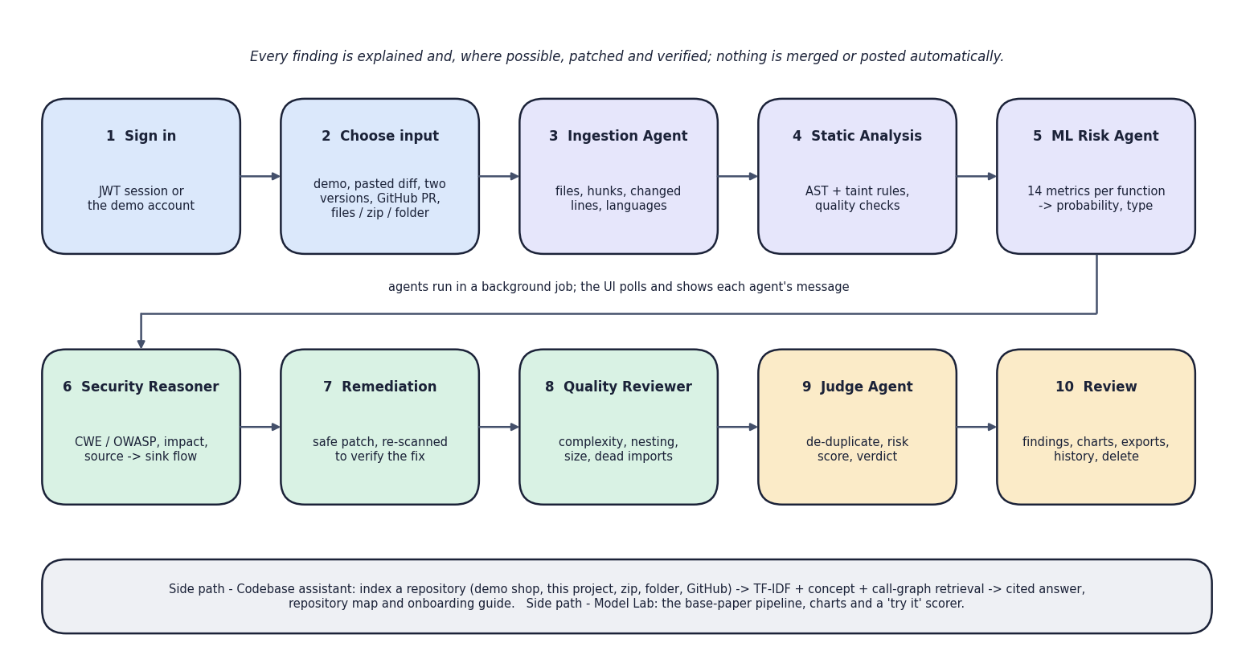
Fig. 1: High-level workflow
The ten steps run in two rows. Steps 1 and 2 are the user's: sign in and choose one of five inputs (the demo, a pasted diff, two versions of a file, a GitHub pull-request link, or files, a zip or a folder). Steps 3 to 9 are the seven agents: Ingestion, Static Analysis, ML Risk, Security Reasoner, Remediation, Quality Reviewer and Judge, run in a background job whose progress the interface polls. Step 10 is the review screen. The grey strip names the two side paths, the codebase assistant and the Model Lab, and the top line states the design rule that nothing is merged or posted automatically.

2 Dataset
The metric model needs labelled functions. The base paper used 21,759 C and C++ functions from ten open-source projects, of which only 275 (1.26 %) were vulnerable, labelled from public vulnerability databases [1]. Those datasets are written in C and C++, are not distributed with the paper, and cannot be analysed by a Python pull-request tool. For this reason the project generates its own corpus of Python functions. This is the most important limitation of the learned component, and every result in this document must be read with it in mind: the model has been shown to learn the patterns the generator contains, not the patterns of real-world vulnerable code.
The generator (autosecai/dataset.py) produces 6,000 functions with a fixed seed. Each function starts as random benign logic whose complexity follows a heavy-tailed choice: it may contain no blocks at all or up to six, drawn from conditionals, loops, nested structures, try blocks, arithmetic, list comprehensions and index expressions. A vulnerable snippet of one of eight types is then inserted at a block boundary, so that the function stays syntactically valid. In 55 % of the non-vulnerable functions a look-alike safe snippet (a hard negative) is inserted instead: a parameterised query, a list-form subprocess call, ast.literal_eval, json.loads, yaml.safe_load, os.path.basename, an escaped HTML fragment, hashlib.sha256, secrets.token_hex or a password read from the environment. Half of the vulnerable snippets read their value directly from a request object, and half use a function parameter. Finally 1 % of the labels are flipped to imitate annotation noise.
Table 2: The eight vulnerability types of the generated corpus
Vulnerability type | Pattern inserted | Functions in the corpus
xss | HTML built from a value by f-string | 75
weak crypto | MD5 digest or predictable random value | 65
sql injection | query built by f-string, concatenation or % | 64
hardcoded secret | password literal passed to a connection | 63
deserialization | pickle, yaml.load or marshal on input | 61
code execution | eval or exec on input | 60
path traversal | open, send_file or remove on an unchecked path | 59
command injection | os.system, os.popen or shell=True with input | 54

Table 3: Dataset summary
Property | Value
Functions | 6,000 (seed 7)
Vulnerable | 501 (8.35 %), after 1 % label noise
Split | 75 % training (4,500) and 25 % test (1,500), stratified, seed 42
Test set | 125 vulnerable and 1,375 safe functions, never balanced
Balanced training set | 8,232 rows after SMOTE and 16 Tomek removals
Licence and provenance | Generated by the project's own code; no third-party data and no licence restriction

Two consequences follow. The analyser's rules and the generator were written by the same team around the same eight weakness classes, so the analyser's score on the corpus is optimistic for real code; and the headline model scores are an upper bound for production code, with no claim of equivalence with the base paper.

3 Data Preprocessing

3.1 Metric extraction
Every function is parsed with Python's ast module and fourteen metrics are measured on it. The metrics are the Python counterparts of the metrics of the base paper [1], which derived them from a code property graph of C and C++ functions. The first eleven keep the families and the numbering of the paper (complexity, size, variables, calls, parameters, index arithmetic in place of pointer arithmetic, input and output calls, nesting, loops and control dependency). Metrics M12 to M14 were added by this project, because injection flaws in Python are not memory flaws and are better indicated by risky calls, string-built call arguments and untrusted sources.
Table 4: The fourteen source-code metrics
Id | Metric | Meaning | Origin
M1 | Cyclomatic complexity | Independent paths (branches) through the function | paper family
M2 | Lines of code | Physical lines of the function body | paper family
M3 | Local variables | Distinct names assigned in the function | paper family
M4 | Call sites | Number of function/method calls (fan-out) | paper family
M5 | Parameters | Variables in the function's argument list (caller-argument metric) | paper family
M6 | Index arithmetic | Subscripts/slices computed with arithmetic (analogue of pointer arithmetic) | paper family
M7 | Vars in index arithmetic | Distinct variables used inside arithmetic subscripts | paper family
M8 | I/O & query calls | open/read/write/execute/send style calls | paper family
M9 | Nested control structures | Deepest nesting of if/for/while/try/with | paper family
M10 | Loops | for/while/comprehension loops | paper family
M11 | Max control dependency | Max number of guarding conditions on any statement | paper family
M12 | Risky API calls | eval/exec/os.system/subprocess/pickle/yaml.load, weak hash/PRNG ... | added by this project
M13 | String-built sinks | Call arguments or returned markup built by f-string/%/format/+ | added by this project
M14 | Untrusted/sensitive sources | request.*, input(), sys.argv, secret-named literals ... | added by this project

3.2 Scaling and balancing
Metric values have very different ranges (lines of code against a count of risky calls), so the selected metrics are scaled to the interval from 0 to 1 with Min-Max scaling fitted on the training data only. The training set is highly imbalanced, so the minority class is enlarged with SMOTE and the result is cleaned with Tomek links [15], [16], [17]. SMOTE draws a minority sample, picks one of its five nearest minority neighbours and creates a new sample on the line between them. A Tomek link is a pair of samples from different classes that are each other's nearest neighbour; the majority-class member of every such pair is removed. Both steps are implemented in the project (about thirty-five lines using scikit-learn's nearest-neighbour search), and they are applied to the training data only, so that the test set keeps its natural class ratio.
Listing: SMOTE as implemented in autosecai/mlmodel.py
def smote(X, y, k=5, seed=SEED):
"""Balance the minority class by interpolating between a sample and its k nearest neighbours."""
rng = np.random.default_rng(seed)
classes, counts = np.unique(y, return_counts=True)
minority, majority = classes[counts.argmin()], classes[counts.argmax()]
Xm = X[y == minority]
need = counts.max() - counts.min()
if need <= 0 or len(Xm) < 2:
return X, y
kk = min(k, len(Xm) - 1)
nn = NearestNeighbors(n_neighbors=kk + 1).fit(Xm)
idx = nn.kneighbors(Xm, return_distance=False)[:, 1:]
base = rng.integers(0, len(Xm), need)
neigh = idx[base, rng.integers(0, kk, need)]
gap = rng.random((need, 1))
synth = Xm[base] + gap * (Xm[neigh] - Xm[base])
return np.vstack([X, synth]), np.concatenate([y, np.full(need, minority)])

4 Algorithm Choice and Justification
Feature selection. Following the base paper, seven methods rank the metrics: absolute Pearson correlation with the label, the coefficients of a linear support-vector machine, Lasso coefficients, the chi-squared statistic, recursive feature elimination with logistic regression, recursive feature elimination with a random forest, and the variance threshold. Each method votes for its five best metrics; the metrics are sorted by votes and, for ties, by mean rank. The paper keeps the top five. This project instead validated the number of metrics k from 5 to 14 on a quarter of the training data and chose k = 13 (validation F1 0.786, against 0.566 for k = 5). The only metric dropped is the number of variables used in index arithmetic (M7), which received no vote.
Classifiers. Nine classifiers were trained, as in the paper: random forest, decision tree, logistic regression, support-vector machine with an RBF kernel, k-nearest neighbours, naive Bayes, gradient boosting, XGBoost [19] and a soft-voting ensemble of random forest, gradient boosting and logistic regression. The model with the best F1 on the held-out data, XGBoost (F1 0.851), is the one stored and used by the ML Risk agent; the random forest (F1 0.826, the winner of the paper) is also kept for the importance chart. F1 was chosen as the selection criterion because accuracy is meaningless when 91.7 % of the functions are safe, and a security tool needs a balance between missed flaws and false alarms.
Why a rule engine as well. A metric model can say that a function looks vulnerable, but not where, why or how to fix it. The AST and taint analyser tracks values from requests and parameters to dangerous calls, names the line and weakness class and can propose a patch. The two detectors fail differently (the measured comparison is given in the testing chapter), which is why the pipeline correlates both kinds of evidence.
Table 5: Consensus of the seven feature-selection methods (training data)
Metric | Votes (of 7) | Mean rank
n_strbuild_args | 7 | 3.71
n_sources | 6 | 3.43
n_danger | 6 | 3.86
n_vars | 4 | 4.29
loc | 3 | 7.14
n_io | 2 | 8.00
n_loops | 2 | 8.14
n_params | 1 | 8.57
max_ctrl_dep | 1 | 9.00
cyclomatic | 1 | 9.14
idx_arith | 1 | 10.14
max_nesting | 1 | 10.71
n_calls | 0 | 7.86
idx_vars | 0 | 11.00

5 Mathematical Formulation
This section states the formulas that the implementation uses. The notation is local to this document.

5.1 Cyclomatic complexity (metric M1)
Following McCabe [21], the complexity of a function is one plus the number of decision points: each if, conditional expression, while, for, exception handler and assertion adds one; each comprehension adds one plus the number of its filters; a boolean expression with n operands adds n - 1; each match case adds one.

5.2 SMOTE and Tomek links
For a minority sample x_i and one of its k = 5 nearest minority neighbours x_nn, a synthetic sample is x_new = x_i + u (x_nn - x_i), where u is drawn uniformly from [0, 1) [15]. The number of samples created is the difference between the sizes of the majority and the minority class. A pair (x_a, x_b) is a Tomek link if their classes differ and each is the other's nearest neighbour [16]; the majority member of the pair is deleted [17].

5.3 Evaluation measures
With TP, FP, FN and TN as the cells of the confusion matrix, precision P = TP / (TP + FP), recall R = TP / (TP + FN), accuracy = (TP + TN) / (TP + FP + FN + TN) and F1 = 2 P R / (P + R). The area under the ROC curve (AUC) is the probability that a random vulnerable function receives a higher score than a random safe one.

5.4 Risk score and verdict
Let the visible findings be f_1 ... f_n. Each has a severity weight s (critical 10, high 6, medium 3, low 1, info 0.2) and a confidence weight c (high 1.0, medium 0.7, low 0.4). Info-level quality findings are skipped. A finding outside the changed lines counts only 15 % of its weight. With w_i = s_i c_i m_i, where m_i is 1 inside the diff and 0.15 outside, the total is W = sum of w_i and the risk score is
score = round( 100 x (1 - exp(-W / 18)) )
The exponential form maps any amount of evidence onto 0-100 with diminishing returns: one medium-severity finding of medium confidence gives a score of 11, and the demo pull request, whose total weight is large, gives 99. The verdict is BLOCK if at least one security finding of high or critical severity with at least medium confidence lies in the changed lines, or if the score is 70 or more; REQUEST_CHANGES if a finding of medium or higher severity lies in the changed lines, or the score is 30 or more; and APPROVE otherwise.

5.5 Retrieval in the codebase assistant
Each function, class or window of a source file is a chunk. Names are split at underscores and capital letters, and chunks are represented by TF-IDF vectors over unigrams and bigrams with sublinear term frequency [22]. For a question q the score of chunk c is
score(c) = cos(q, c) + 0.30 x max concept affinity(c) / 2 + 0.5 [name(c) = identifier in q] + 0.1 [path(c) contains a long token of q]
then multiplied by 1.15 for function chunks and 1.05 for class chunks. The affinity of a chunk to each of eight concepts (authentication, routing, user interface, database, configuration, tests, security controls, entry points) is computed from keyword counts in the code and from matches in the path, capped at 2. For the five strongest chunks a personalised PageRank [23] is run on the import and call graph with damping 0.6 and the scores as the personalisation vector; its normalised value times 0.08 is added to every chunk. Chunks with a final score of at most 0.02 are discarded and the top k (default 6) are returned.

6 Model Architecture and Training
Training is a single function, train_all(), which takes 31.7 s on the development machine (Intel Core i5-12500, 12 threads, no GPU). It generates the corpus, splits it, selects features on the training part, balances it, fits the nine classifiers, evaluates them on the untouched test part, runs the ablation, trains the type classifier and writes the model bundle, the report and two CSV files. All random choices use fixed seeds. The hyper-parameters were not tuned with a grid search (the paper used one [1]); they are library defaults except where listed.
Table 6: Model configuration
Model | Configuration
Random forest | 300 trees, seed 42
Decision tree | maximum depth 12
Logistic regression | up to 2,000 iterations
SVM | RBF kernel, probability estimates on
k-nearest neighbours | k = 7
Naive Bayes | Gaussian
Gradient boosting | library defaults, seed 42
XGBoost | 200 trees, depth 5, learning rate 0.1, log-loss
Voting ensemble | soft vote of random forest (200 trees), gradient boosting and logistic regression
Type classifier | random forest, 400 trees, class-balanced, 14 metrics, trained on the vulnerable functions only

Table 7: Results of the nine classifiers on the 1,500 held-out functions
Model | Accuracy | Precision | Recall | F1 | AUC
Random Forest | 0.973 | 0.882 | 0.776 | 0.826 | 0.953
Decision Tree | 0.953 | 0.682 | 0.824 | 0.746 | 0.896
Logistic Regression | 0.879 | 0.401 | 0.920 | 0.558 | 0.945
SVM (RBF) | 0.933 | 0.563 | 0.856 | 0.679 | 0.929
KNN | 0.901 | 0.448 | 0.832 | 0.583 | 0.924
Naive Bayes | 0.877 | 0.397 | 0.920 | 0.554 | 0.936
Gradient Boosting | 0.949 | 0.650 | 0.832 | 0.730 | 0.937
XGBoost (stored) | 0.977 | 0.942 | 0.776 | 0.851 | 0.937
Voting Ensemble | 0.963 | 0.738 | 0.856 | 0.793 | 0.956

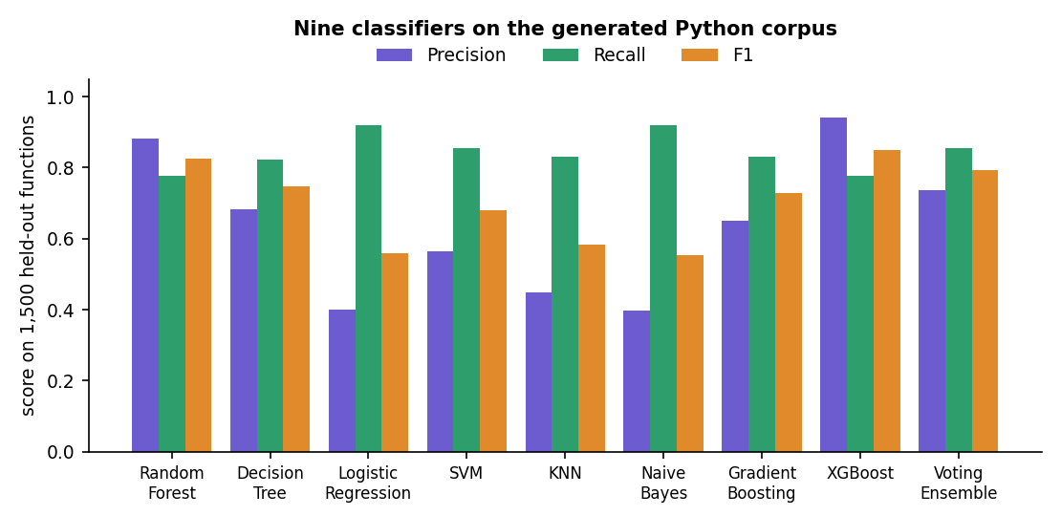
Fig. 2: Precision, recall and F1 of the nine classifiers
XGBoost gave the best F1 (0.851) through the highest precision (0.942), at the same recall as the random forest (0.776). Logistic regression and naive Bayes had the highest recall (0.920) but a precision near 0.40, which would flood a reviewer with false alarms.
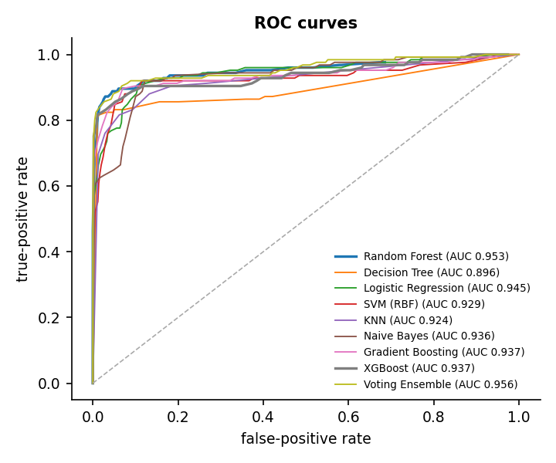  Fig. 3: ROC curves of the nine models | 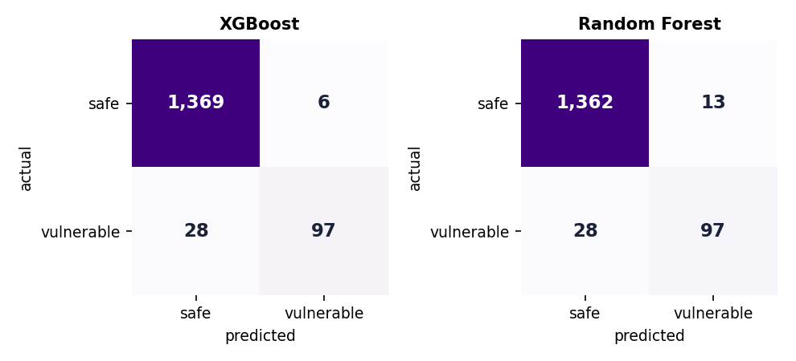  Fig. 4: Confusion matrices of XGBoost and Random Forest

6.1 Ablation, feature count and stability
Table 8: Ablation of the random forest
Random-forest configuration | Precision | Recall | F1
RF - all 14 metrics, no balancing | 0.933 | 0.776 | 0.847
RF - top-5 metrics + SmoteTomek (paper setting) | 0.643 | 0.648 | 0.645
RF - top-13 metrics + SmoteTomek (this system) | 0.882 | 0.776 | 0.826

All fourteen metrics without balancing gave the best F1 (0.847); the paper's top-five setting with SMOTE-Tomek gave only 0.645; the system's setting (top 13 with balancing) gave 0.826. Recall is the same (0.776) with and without balancing and balancing lowered precision, so on this corpus it did not help; but the configurations differ in the number of metrics as well, so the effects cannot be separated and no single-factor experiment was run. The sweep shows that the taint-oriented metrics matter: five metrics lower the validation F1 from 0.786 to 0.566.
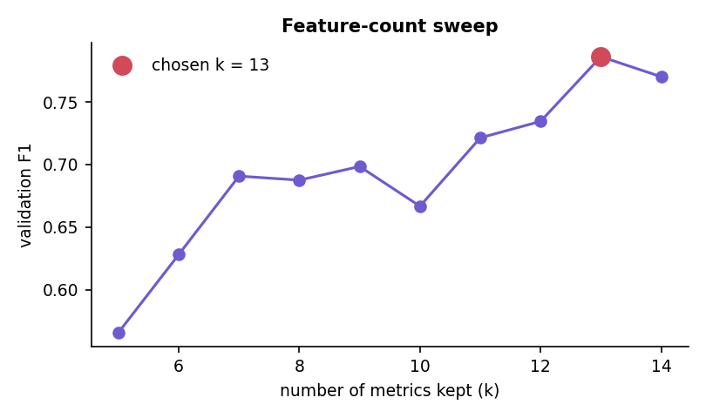  Fig. 5: Validation F1 against the number of metrics kept | 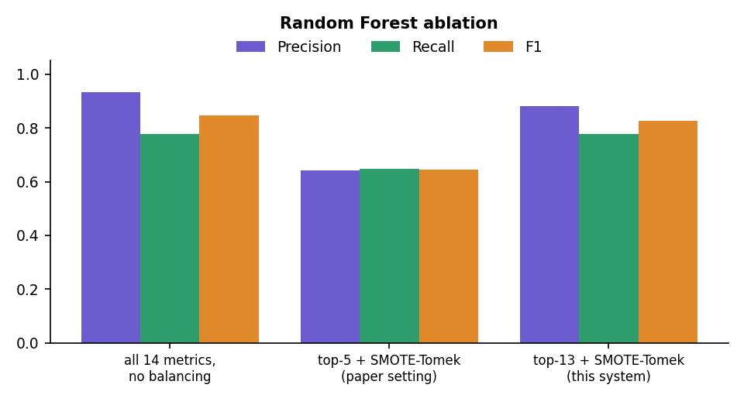  Fig. 6: Ablation of the random forest

To check that the result is not an accident of one random corpus, the Random Forest and XGBoost pipelines were repeated on five corpora generated with different seeds (k fixed at 13, same split rule). The first seed reproduces the stored report exactly.
Table 9: Five independently generated corpora
Corpus seed | Vulnerable | RF F1 | RF precision | RF recall | XGB F1 | XGB precision | XGB recall
7 | 501 | 0.826 | 0.882 | 0.776 | 0.851 | 0.942 | 0.776
11 | 493 | 0.800 | 0.860 | 0.748 | 0.842 | 0.949 | 0.756
23 | 545 | 0.818 | 0.910 | 0.743 | 0.840 | 0.953 | 0.750
41 | 517 | 0.818 | 0.856 | 0.783 | 0.840 | 0.895 | 0.791
59 | 484 | 0.809 | 0.875 | 0.752 | 0.836 | 0.929 | 0.760
Mean +/- sd |  | 0.814 +/- 0.010 |  |  | 0.842 +/- 0.006

The headline F1 of 0.851 for XGBoost is the best of the five seeds; the mean is 0.842 with a standard deviation of 0.006. For the random forest the headline 0.826 is also the best seed (mean 0.814 +/- 0.010). XGBoost ranks above the random forest on all five seeds, which supports the stored choice. The number of metrics was not re-selected per seed.
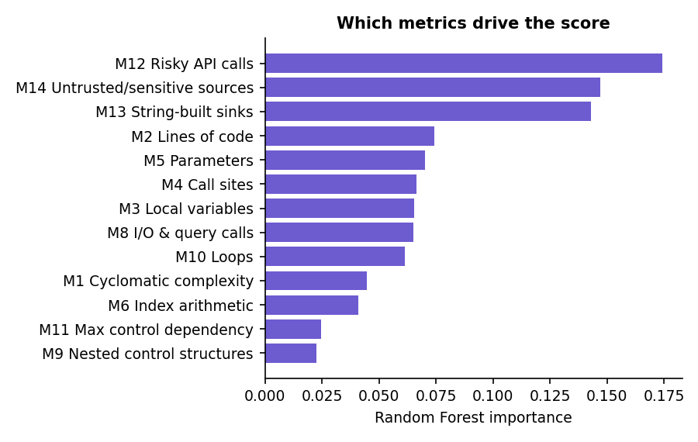  Fig. 7: Random-forest importance of the selected metrics | 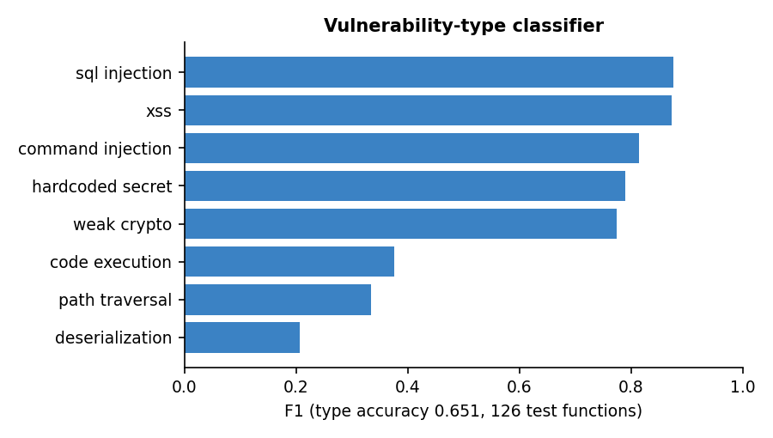  Fig. 8: F1 of the vulnerability-type classifier

Risky API calls, untrusted sources and string-built sinks carry about 46 % of the importance; the paper's complexity metrics matter less for these injection-type flaws. The type classifier reaches an accuracy of 0.651 on 126 functions (macro F1 0.630): reliable for SQL injection, XSS, command injection, weak cryptography and hard-coded secrets (F1 0.77 to 0.88), unreliable for deserialization (0.21), path traversal (0.33) and code execution (0.38).

7 Base Paper Analysis
Base paper. B. K. E. Abbasi and A. Shameli-Sendi, "Leveraging key source code metrics for predicting software vulnerabilities with machine learning," IEEE Access, vol. 14, pp. 52610-52625, 2026, doi: 10.1109/ACCESS.2026.3679930.
Problem and data. Abbasi and Shameli-Sendi ask which properties of source code make a function vulnerable, and whether the same properties reveal the type of vulnerability. They collected 21,759 functions from ten open-source C and C++ projects (including SQLite, FreeType, LibTIFF, Libxslt, Binutils, FFmpeg, ImageMagick, OpenSC and rdesktop, and OpenSSL according to the abstract). Only 275 of them, about 1.26 %, are vulnerable. Six projects were used for training and testing and four (FFmpeg, ImageMagick, OpenSC and rdesktop) only for testing. Vulnerable functions are labelled with eight types, taken from the CVE and NVD databases: denial of service, buffer overflow, memory corruption, SQL injection, code execution, bypass, gain of sensitive information and gain of privilege.
Method. The source code is parsed by a fuzzy parser (ANTLR grammar, Joern tool) into a code property graph that combines the abstract syntax tree, the control-flow graph and the program-dependence graph. Fourteen metrics, M1 to M14, are computed from the graph, among them cyclomatic complexity (M1), the number of variables in the arguments of the caller (M5), pointer-arithmetic counts (M6, M7), nested control structures (M9) and control dependency (M11). Seven feature-selection techniques (Pearson correlation, a support vector machine, Lasso, chi-squared, RFE with logistic regression, RFE with a random forest and a variance threshold) each rank the metrics, and the five that recur are kept. The classes are balanced with SmoteTomek [17], the metrics are scaled with Min-Max normalisation, and nine machine-learning models are trained, with their hyper-parameters set by grid search and evaluated with repeated k-fold cross-validation. The same procedure is applied to eight smaller datasets, one per vulnerability type.
Reported results. The five metrics found most important for predicting vulnerability were M5, M6, M1, M9 and M11. The Random Forest was the best of the nine models, with an accuracy of 0.96, a precision of 0.948, a recall of 0.974 and an F1-score of 0.961. Across all projects the model found 261 of the 275 vulnerable functions, compared with 244 in the authors' earlier work. For denial-of-service vulnerabilities, the Random Forest reached an accuracy of 0.972 and an F1-score of 0.972, against an accuracy of 0.89 in the earlier work.
Limitations stated by the authors. Code property graphs rest on static analysis, so conservative approximations can add false edges, and macros and compiler extensions can disturb the syntax tree. The grammar is limited to C and C++; the authors propose extending the framework to Python and Java and combining the models with autonomous security systems.
What AutoSecAI adopts. The central idea, that a small set of interpretable source-code metrics, chosen by several selectors and used with a balanced training set, separates vulnerable from safe functions, and that the metrics also hint at the vulnerability type. The Model Lab reproduces the full pipeline: fourteen metrics, the same seven selectors with a vote-and-rank consensus, SMOTE and Tomek-link cleaning, Min-Max scaling, nine classifiers and a type classifier. The paper's Python-and-Java future work is the starting point of the adaptation.
What AutoSecAI changes. The data (generated Python functions instead of real C and C++ projects), the metric source (the Python ast module and an analogue of control dependency instead of a code property graph), three added metrics (M12 risky API calls, M13 string-built sinks, M14 untrusted sources) that capture how Python injection flaws arise, the number of metrics kept (chosen by a validation sweep from 5 to 14 rather than fixed at five), and above all the setting: the model is one agent of a pull-request pipeline that also runs rule-based taint analysis, explains each finding, proposes verified patches and gives a merge verdict. The paper evaluates a classifier; this project builds a reviewer around one.
Why the results cannot be compared directly. The evaluations differ in language, in the origin of the data (real projects labelled from CVE records against generated code with injected patterns), in class balance (1.26 % against 8.35 % vulnerable) and in test protocol; Chapter 8 repeats this caution beside the numbers.

8 Novelty Compared with the Base Paper
The base paper [1] predicts, offline, whether a C or C++ function is vulnerable from 14 source-code metrics, and classifies the type of vulnerability. AutoSecAI keeps that signal and moves it into the place where code is actually reviewed: the pull request. The table lists what differs; none of it is claimed as new to the field, and the system's accuracy figures are not comparable with the paper's because the language, the data and the class balance are different.
Table 10: What is new compared with the base paper
Element | Base paper [1] | AutoSecAI (new here)
Setting | Offline classification of functions in 10 open-source C/C++ projects | Inside a pull-request workflow: diff ingestion, per-function scoring of the changed code, verdict, report
Language | C / C++ (code property graph) | Python AST for the metrics and the taint rules; regex rules for JavaScript, PHP and Java
Metrics | 14 metrics M1-M14 from a code property graph | Python analogues of the same families (M1-M11) plus three taint-oriented metrics M12-M14 (risky calls, string-built sinks, untrusted sources)
Evidence beyond the score | Feature importance only | AST/taint rule engine with source-to-sink evidence; CWE and OWASP mapping; explanation, impact and remediation text
Remediation | Not addressed | Auto-generated patches that are re-scanned and kept only if the finding disappears
Decision | Class label | Risk score 0-100 and a merge verdict (APPROVE, REQUEST_CHANGES, BLOCK) from an explicit, documented rule
Agents | Single model pipeline | Seven cooperating software agents with a visible trace; an optional LLM text layer, off by default
Codebase context | Not addressed | Repository assistant: TF-IDF, concept scores and call-graph retrieval answer questions with evidence
Interfaces | Scripts | FastAPI service with login, background jobs, exports (Markdown, SARIF, JSON, CSV) and a React web application
Evidence | Accuracy, precision, recall, F1 on real projects | Same metrics on a generated Python corpus, five-seed repeat, rule-engine-versus-model study, latency, retrieval test, 17 automated tests

9 Key Contributions
1. A seven-agent pull-request reviewer with an auditable trace. Ingestion, Static Analysis, ML Risk, Security Reasoner, Remediation, Quality Reviewer and Judge agents run in sequence; each records its role, duration, summary and details, and the interface shows them live as the job runs. The built-in demo pull request (1 file, +67/-1 lines) is reviewed in a median of 0.375 s and yields 17 findings, a risk score of 99 and a BLOCK verdict.
2. An AST and taint engine for Python with a rule knowledge base. 30 security rules and 12 quality rules, each mapped to a CWE and an OWASP category with an explanation, impact, remediation and safe pattern. On the 1,500 held-out functions the engine alone reached precision 0.926, recall 0.704 and F1 0.800.
3. Verified auto-fixes. For SQL injection, shell commands and similar classes the Remediation Agent rewrites the code, re-analyses the result and keeps the patch only if the finding has disappeared; on the demo pull request 7 of 7 patches were verified.
4. A Python adaptation of the base-paper metric model. Fourteen AST metrics (M1 to M11 follow the paper's families; M12 to M14 for risky calls, string-built sinks and untrusted sources were added for Python injection flaws), seven feature selectors, SMOTE-Tomek implemented from scratch, and nine classifiers. XGBoost gave F1 0.851 (mean 0.842 over five corpus seeds) on a generated corpus.
5. Evidence that the two detectors complement each other. Flagging a function when either the rule engine or the model flags it raised F1 to 0.891 (recall 0.880) from 0.851 for the model and 0.800 for the rules alone, on the same held-out functions.
6. A repository assistant for code comprehension. TF-IDF similarity, concept scores for authentication, routing, database and other themes, and personalised PageRank over an import and call graph; on twelve hand-written questions about the demo repository the expected file ranked first for 8 and in the first three for 11.
7. Standard outputs and a complete application. Markdown, SARIF 2.1.0, JSON and CSV exports; a FastAPI service of 25 routes, JWT authentication and a React 19 interface with every state designed.
8. A repeatable test and measurement suite. 17 automated tests, a 16-check API smoke test, 22 browser flows, and a measurement script that re-computes the engine, seed, latency and retrieval figures quoted in this report.
Contributions 1, 3, 7 and 8 are engineering contributions; contributions 2, 4, 5 and 6 are the elements whose quality was measured. Compared with the base paper [1], this project moves the technique into the pull-request workflow, adapts it to Python and adds taint-oriented metrics, rule-based analysis, explanation, patching and repository context. The ML measurements are made on a generated corpus, so they show that the pipeline works, not how well it would score on real vulnerabilities.

